**Purpose Statement:**

Given “disks” of different radii, determine the relationship between the mass and radius of the disks through a graphical method. In using graphical methods, we will learn about linearization and the use of it to create a mathematical model.

**Procedure:**

1. Find the radius of the discs with a ruler
2. Find the mass of the discs using scale
3. Graph the data on a non linear graph
4. Record equation
5. Change the axis and linearize graph
6. Record graph and equations

| **Height(mm)** | **Mass(g)** | **Radius** |  | **Radius Squared** |
| --- | --- | --- | --- | --- |
| 0.003125 cm | 0.69 g | 6.75 cm |  | 45.256 cm2 |
| 0.003125 cm | 0.36 g | 5.25 cm |  | 27.5625 cm2 |
| 0.003125 cm | 0.21g | 4.25 cm |  | 18.0625 cm2 |
| 0.003125 cm | 0.13 g | 3.25 cm |  | 10.6525 cm2 |
| 0.003125 cm | 0.06 g | 2.25 cm |  | 5.0625 cm2 |

Volume and mass increase proportionally (because the density is the same) so the only thing that is changing in this lab is the area which is piR2 so it is changing proportionally to r2. Since everything else is constant, we are able to ignore them and we are given a linear relationship between r2 and mass.

Graph #1 : Mass vs. Radius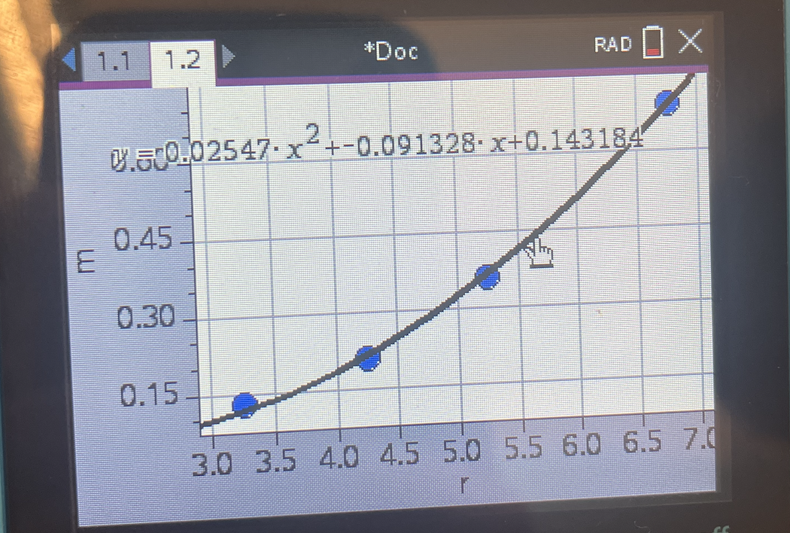

Equation: 0.02547x^2- 0.091328x + 0.143184

Graph #2: Linearization of Graph #1 (Mass vs radius2)

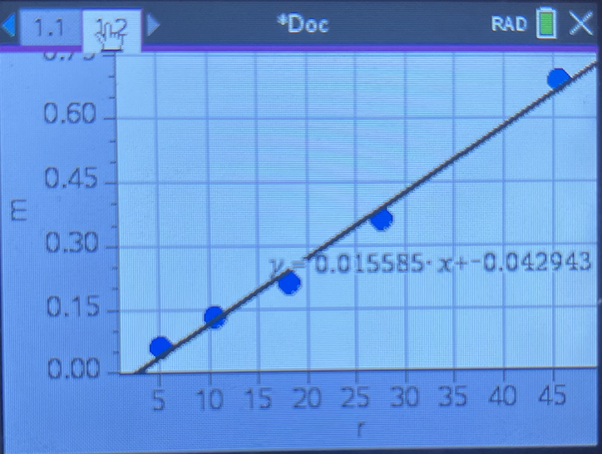

Equation: 0.015585x -0.042943

Work:

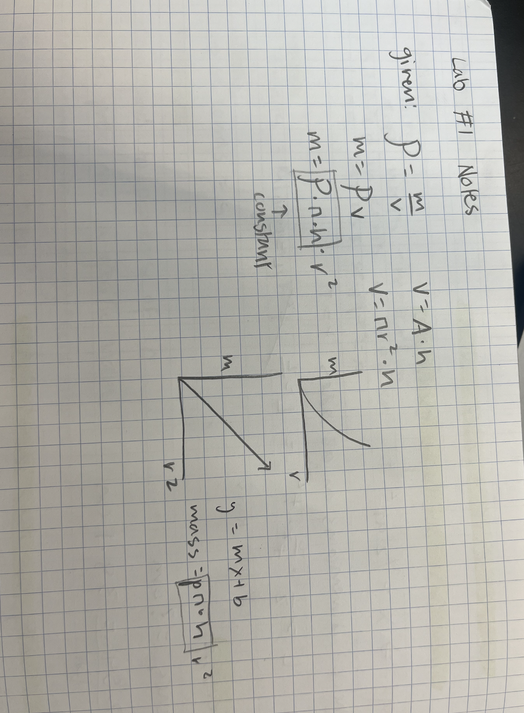

Analysis Questions

1. Considering the mathematical relationship between disk radius r and disk mass m

(equation 4), what does the independent variable from your line of best fit represent?

* The independent variable from the line of best fit represents the radius of the aluminum disk because the mass is dependent on the radius therefore the radius is considered the independent variable

2. Use the mathematical relationship between mass of the disk m and the disk's

radius r to equate the coefficient values from your line of best fit to physical

quantities. What are the units for each?



The slope represents the constants (density, pi, and height). In the equation that we made, the slope shows that mass and radius^2 are proportional.

3. Should you adjust the best-fit line to be sure it passes through the origin, (0,0)?

Justify your answer.

No, you shouldn’t, because the y-intercept can help show that the data has an error, and moving it to fit (0,0) would hide the error and display false results.

4. Using the slope of your best fit line and your measured value for disk thickness,

determine the experimental value for the disk material density. How does this value

compared to the theoretical value provided by your teacher? What is your percent

Error?

Theoretical density = 2.7 g/cm^3

Percent difference = 42.8%

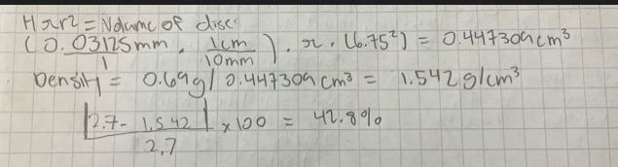

5. What are some of the factors that may have caused error and how might these

Factors have been prevented?

Some of the factors that may cause the error are manual and non digital measurement. For example the radius measurements and the thickness measurements. To prevent these human errors, we could use digital measurements to get the exact values.

**Synthesis Questions:**

1. In this experiment, if we had used disks with a greater thickness, would the slope of your best fit line have been different? Would your experimental value for density be the same? Explain.

The slope of the line of best fit would change because if the thickness increases, the mass would increase and in order for the equation to stay accurate, the slope will have to increase because mass is the dependent variable. The density would be the same because mass and the volume would still increase proportionally.

1. How would your graph of m versus r2 be different if you had used disks of the same thickness, but made out of steel? Draw a second line on your m versus r2 plot that represents disks made of steel.

The line would be different because the slope would be different. The density of steel is 7.85 g/cm^3 however the density of aluminum is 2.7 g/cm^3. In this lab, the slope is pi*height*density and since the density is different by a factor of 2.5, the slope of the steel graph will be 2.5 times greater.

Aluminum equation/graph: 0.015585x -0.042943

Steel equation/graph: 0.035067x-0.096621

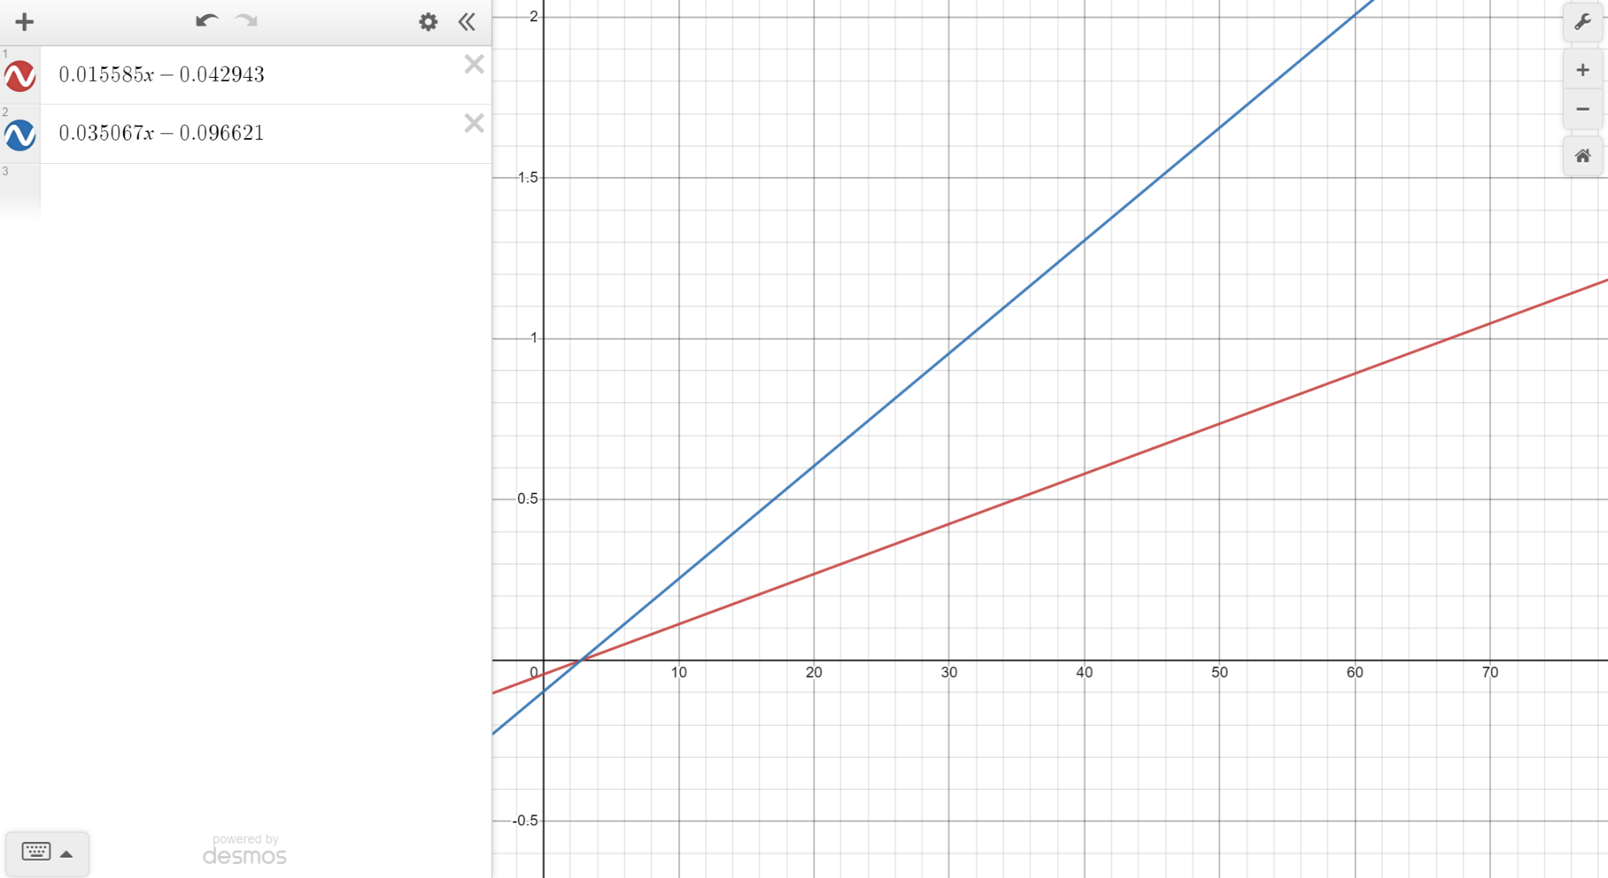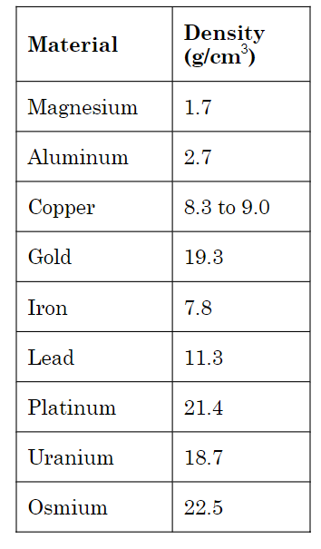

3. Another group of students has acquired data for the exact same experiment;

however, their disks are made of an unknown material that they are trying to

determine. The group's m versus r2 data produced a line of best fit with slope equal to 122 kg/m2. Each disk they measured had the same 0.5 cm thickness. Calculate the density of the unknown material and use the table below to help determine what material their disks are made of.

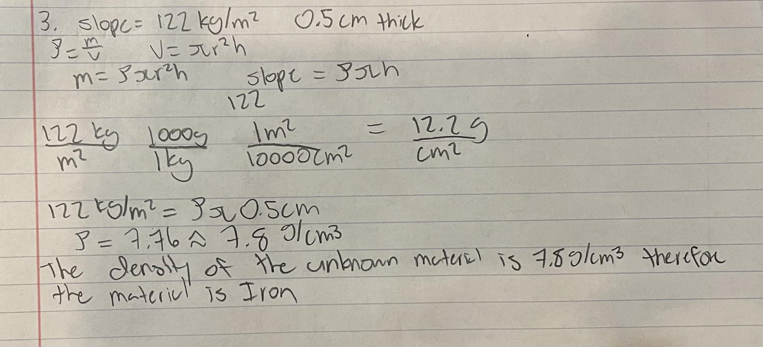

Multiple Choice questions:

1. You perform the same experiment, but this time you plot a linear relationship

between mass and the circumference of the disks rather than the radius. What is the

slope of the linear plot?

E

3. Consider an experiment in which a student measures the mass and diameter of 10

different-sized spheres, all made of the same material of uniform density ρ. For this

student to create a linear graph relating the mass of the sphere to its radius r, the

student would need to plot mass m versus which quantity:

C

